AWS VPC Networking Lab (Public + Private Subnet)
Lab Goal
Create a custom network with:
- 1 VPC
- 2 Public Subnets
- 2 Private Subnets
- Internet Gateway
- Route Tables
- EC2 Instances
- SSH from Public EC2 → Private EC2

1. Create VPC
Go to VPC → Create VPC
Setting | Value
Name | student-vpc
IPv4 CIDR | 10.0.0.0/16
Tenancy | Default
Result
student-vpc
10.0.0.0/16

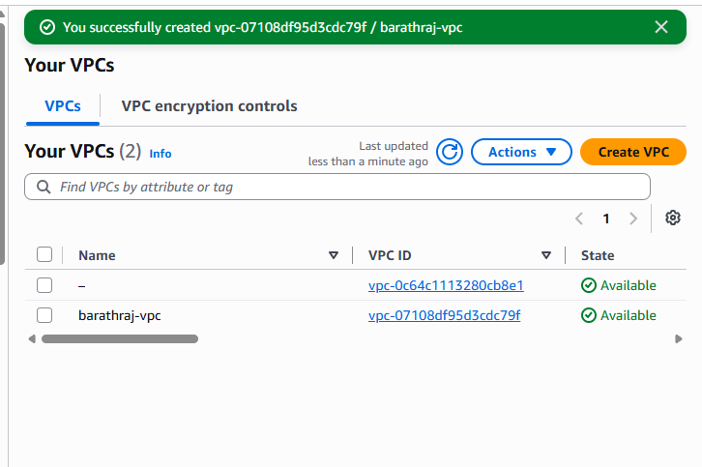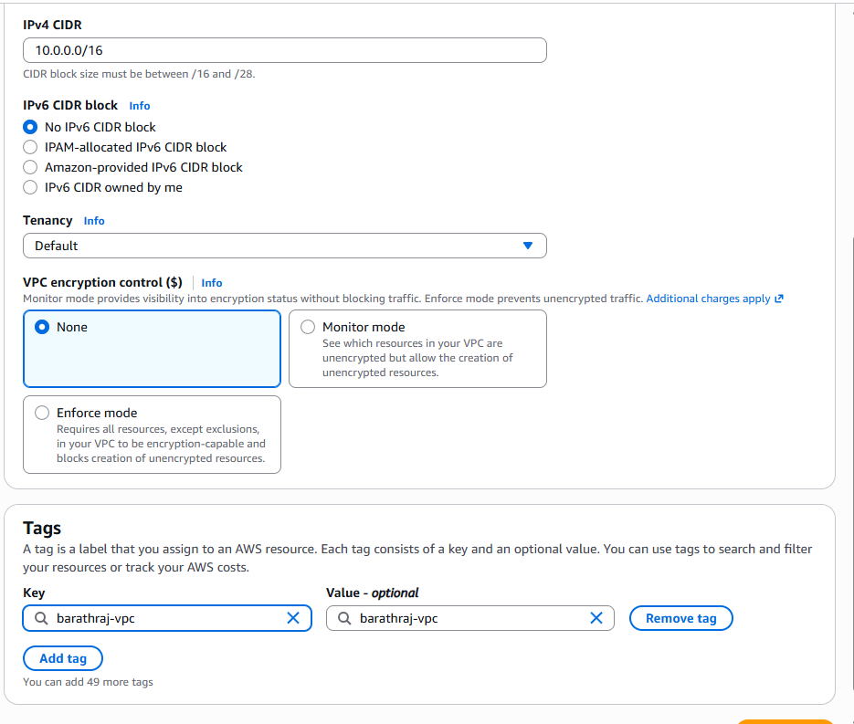

2. Create Subnets
Go to Subnets → Create Subnet
Public Subnet 1
Setting | Value
Name | student-public-subnet-1a
AZ | ap-south-1a
CIDR | 10.0.1.0/24
Enable:
Auto Assign Public IP = Enable
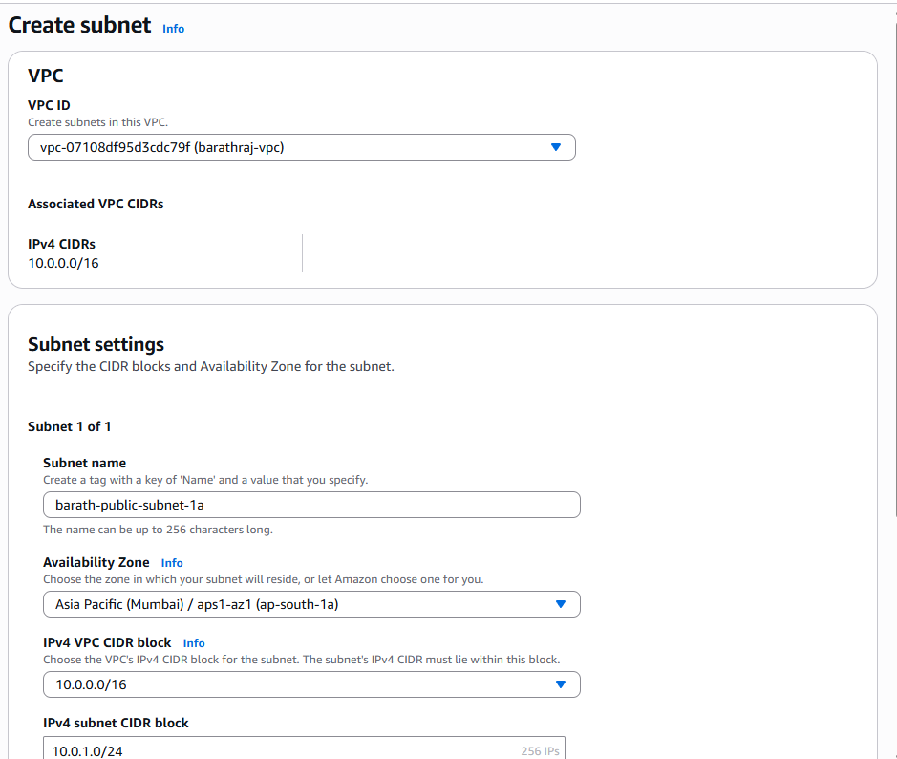
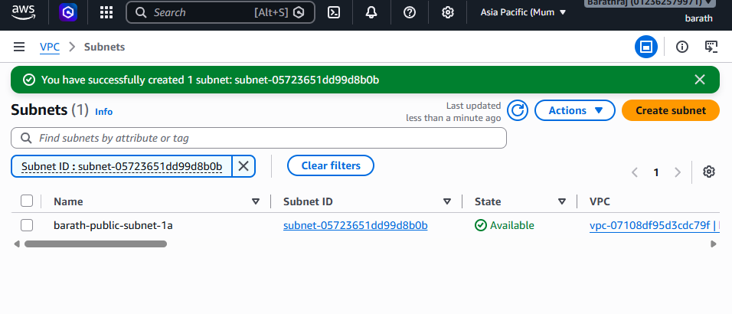
Public Subnet 2
Setting | Value
Name | student-public-subnet-1b
AZ | ap-south-1b
CIDR | 10.0.2.0/24
Enable:
Auto Assign Public IP = Enable
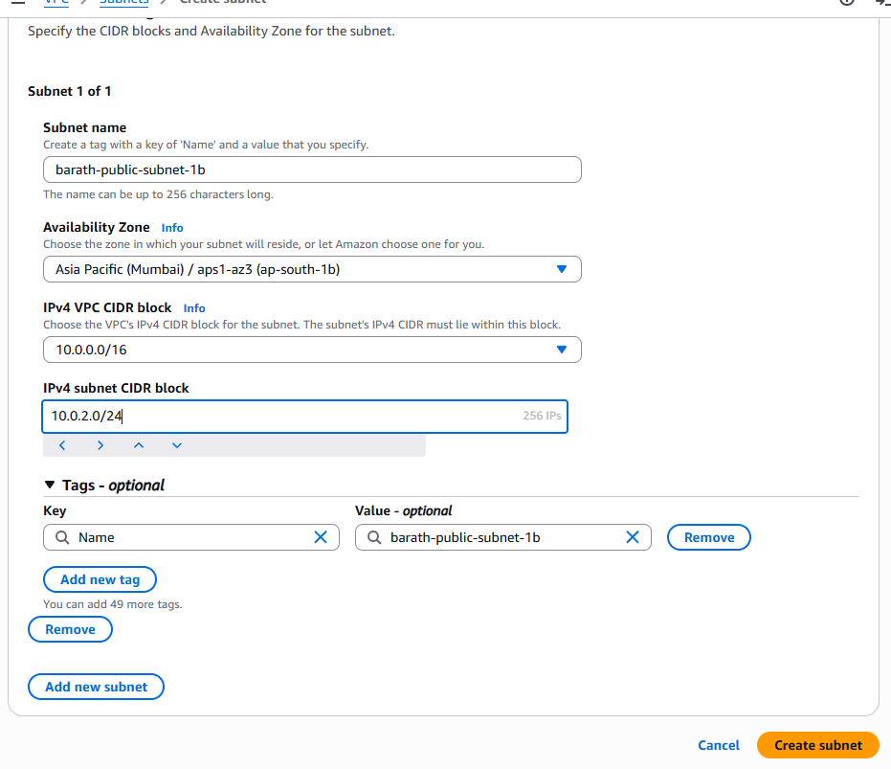
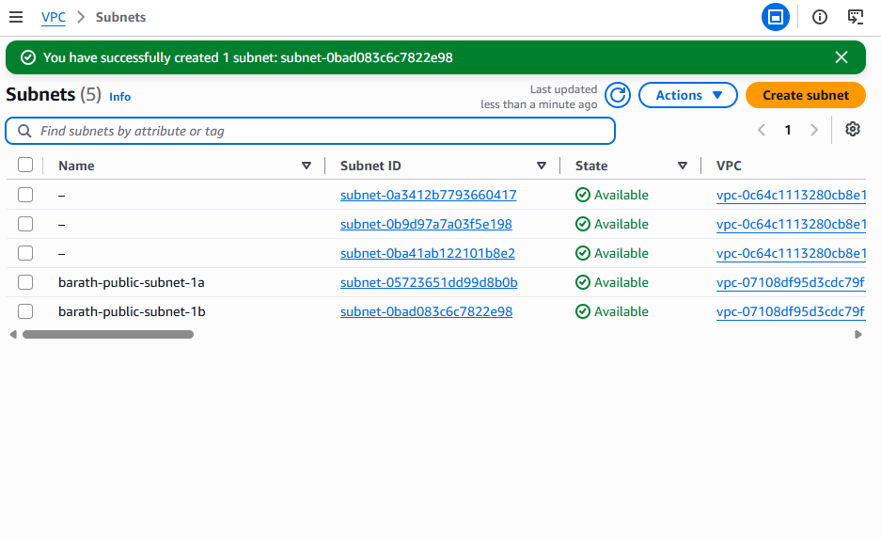
Private Subnet 1
Setting | Value
Name | student-private-subnet-1a
AZ | ap-south-1a
CIDR | 10.0.3.0/24
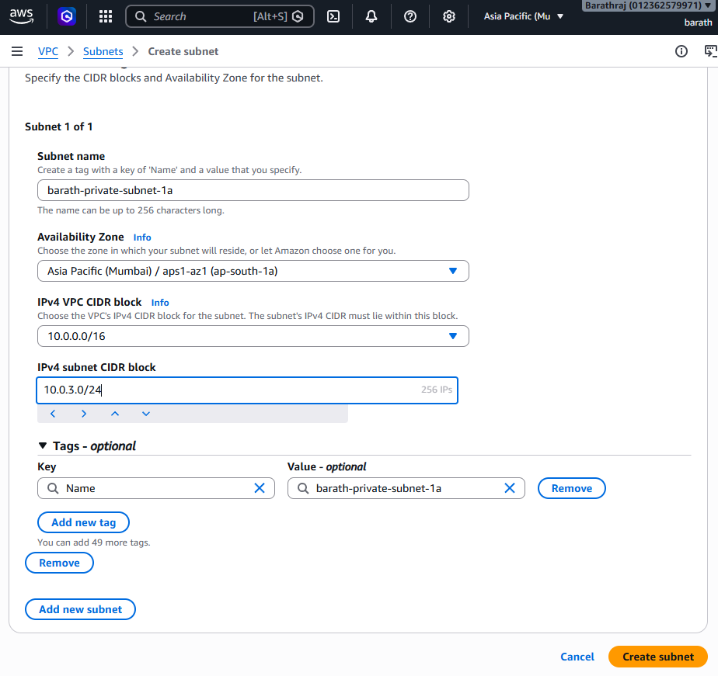
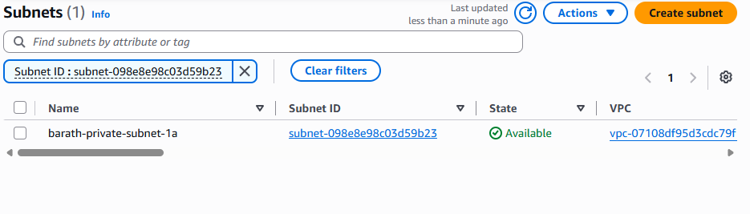

Private Subnet 2
Setting | Value
Name | student-private-subnet-1b
AZ | ap-south-1b
CIDR | 10.0.4.0/24
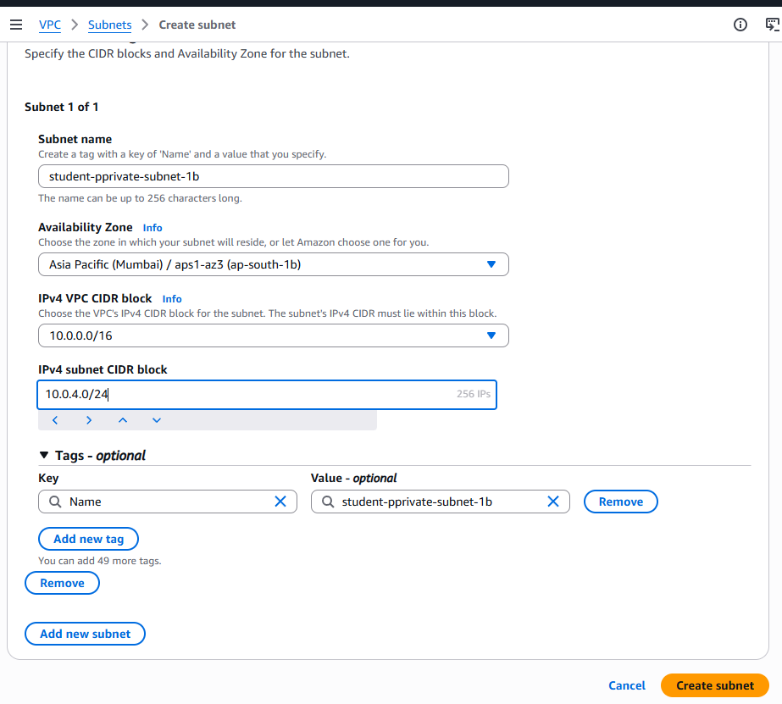
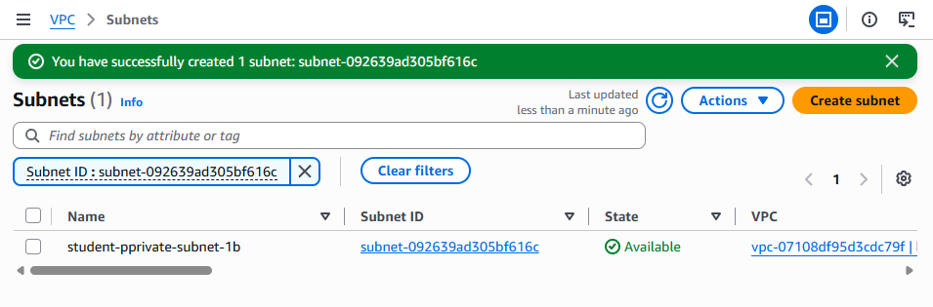

3. Create Internet Gateway
Go to Internet Gateway → Create
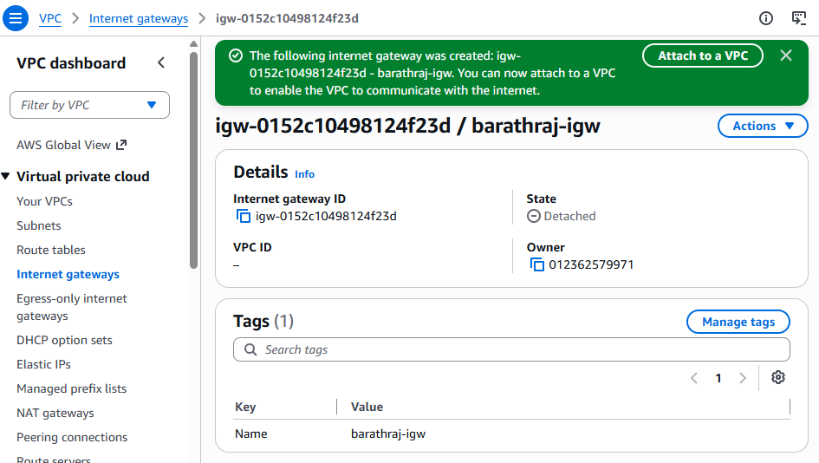
Name
student-igw
Attach it to student-vpc
student-igw → Attach → student-vpc
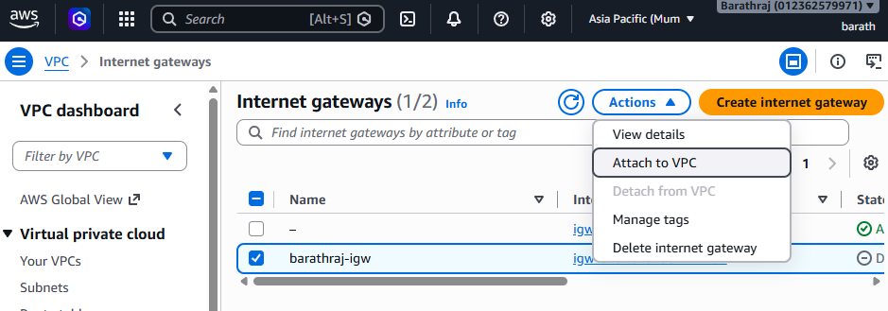
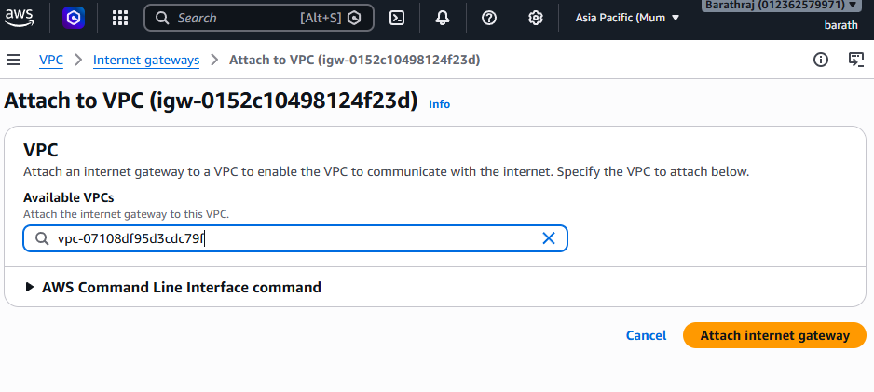

4. Create Public Route Table
Go to Route Tables → Create
Name
student-public-rt
Attach to VPC: student-vpc
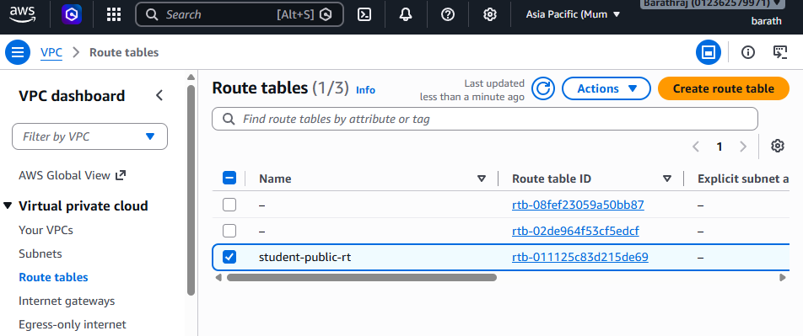

Add Route
Edit routes
Destination: 0.0.0.0/0
Target: student-igw
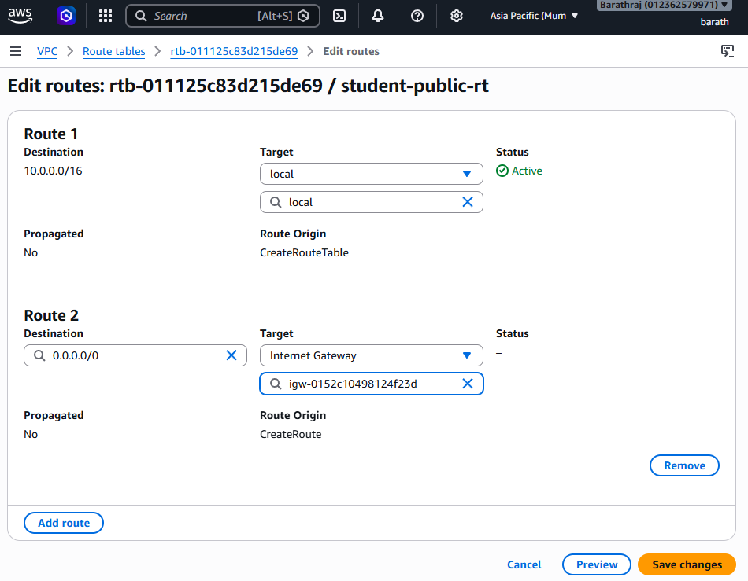

Attach Public Subnets
Subnet Associations:
Attach
student-public-subnet-1a
student-public-subnet-1b
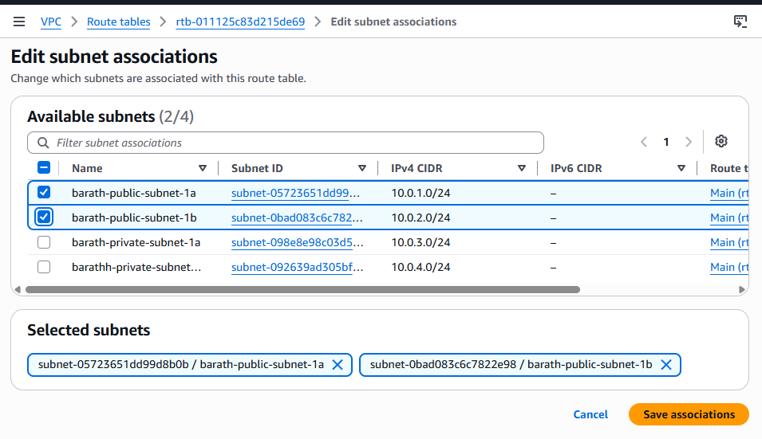

5. Create Private Route Table
Create another route table
Name
student-private-rt
Attach to student-vpc
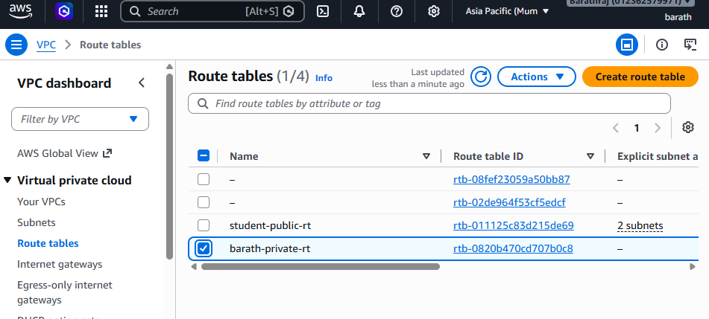

Attach Private Subnets
Associate
student-private-subnet-1a
student-private-subnet-1b
(No internet route)
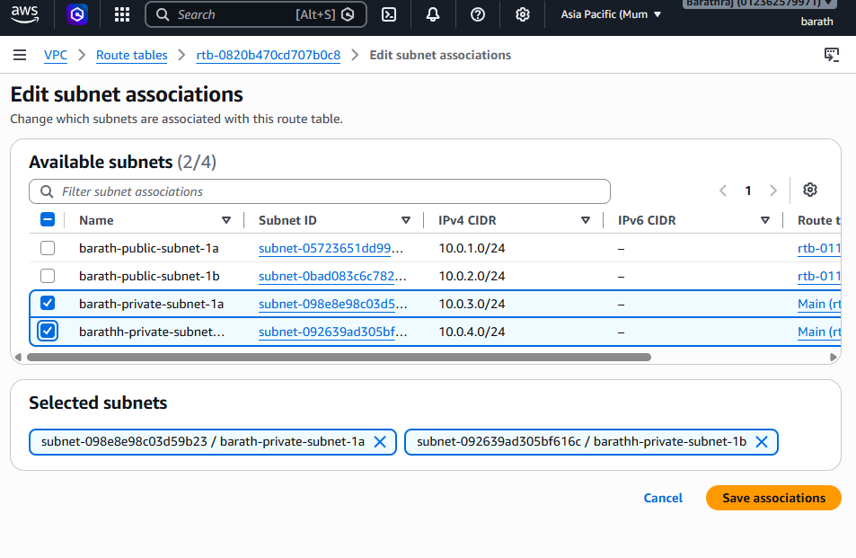

6. Create Security Group
Go to EC2 → Security Groups
Create
Name
student-sg
Inbound Rules
Type | Source
SSH | 0.0.0.0/0
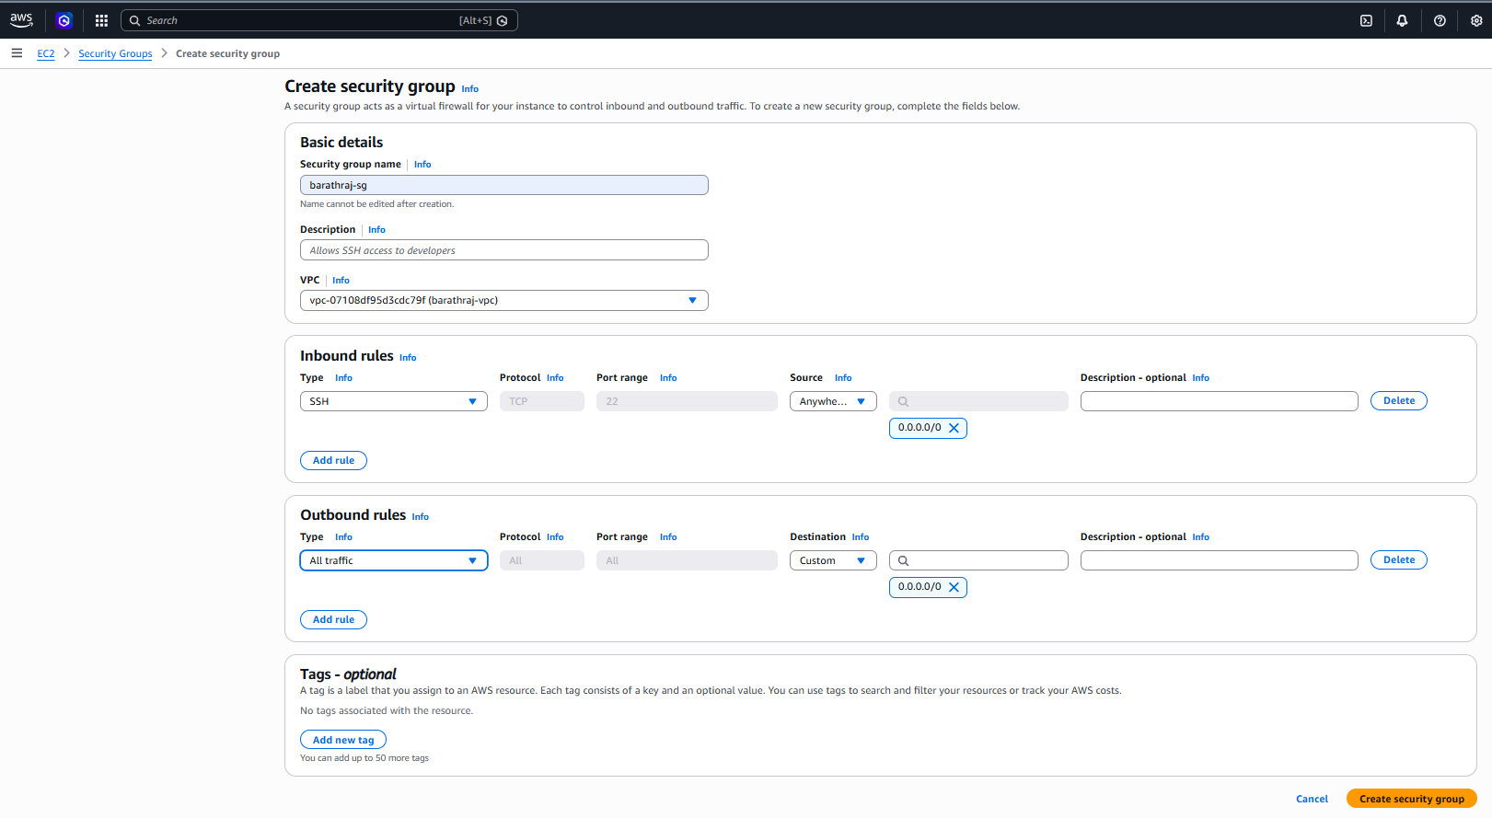
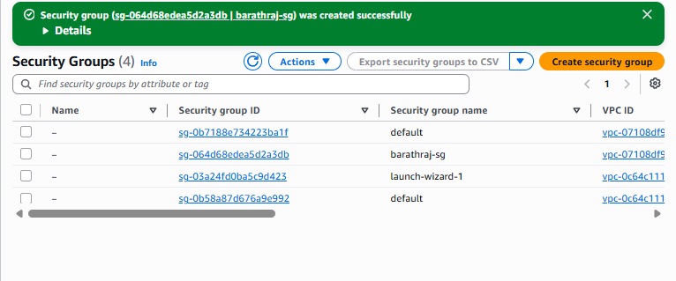

7. Launch Public EC2
Go to EC2 → Launch Instance
Setting | Value
Name | student-public-ec2
AMI | Amazon Linux
Instance | t2.micro
VPC | student-vpc
Subnet | student-public-subnet-1a
Auto assign public IP | Enable
Security Group | student-sg
Launch
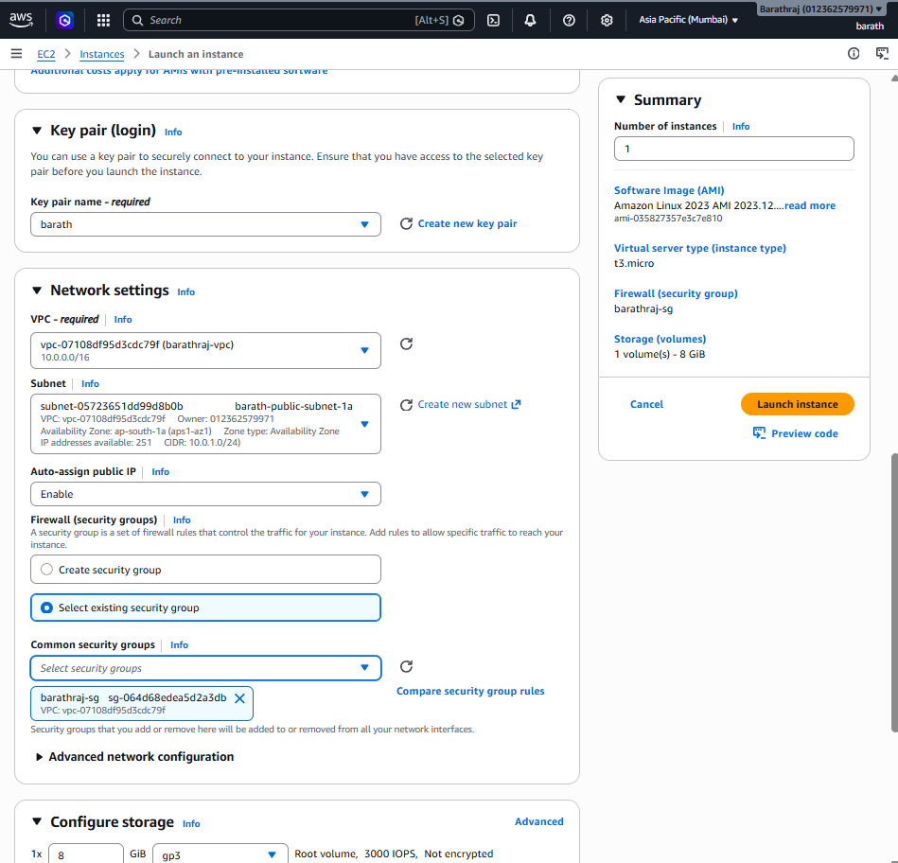
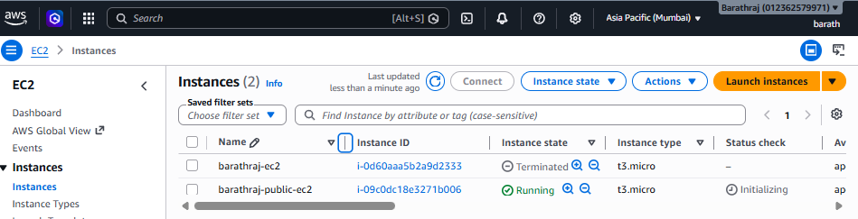

8. Launch Private EC2
Setting | Value
Name | student-private-ec2
AMI | Amazon Linux
Instance | t2.micro
VPC | student-vpc
Subnet | student-private-subnet-1a
Public IP | Disable
Security Group | student-sg
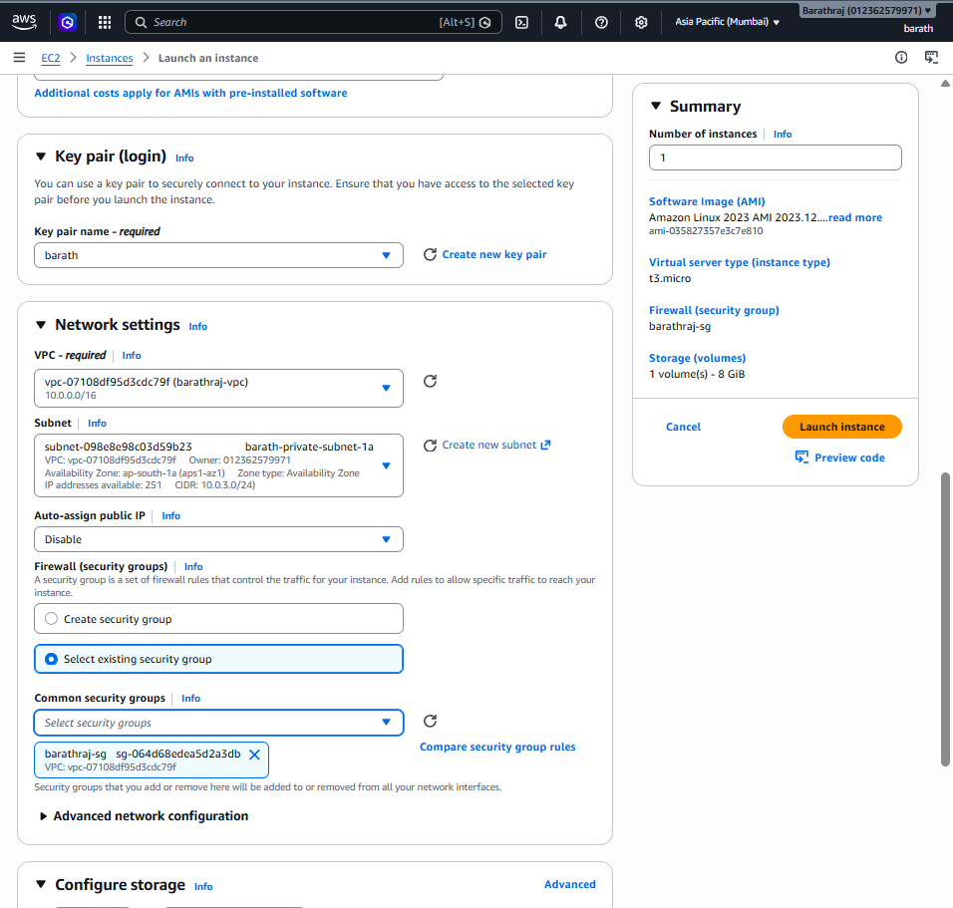
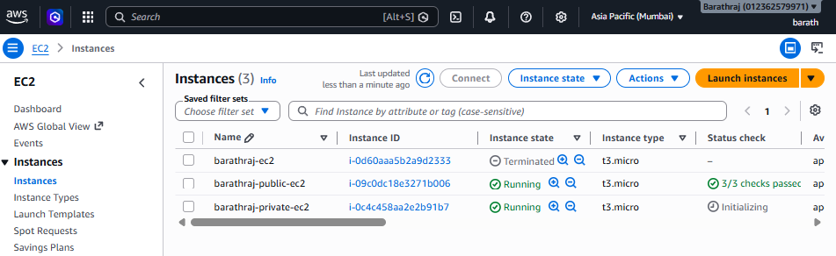

9. Connect to Public EC2
SSH from your laptop
ssh -i student-key.pem ec2-user@PUBLIC-IP
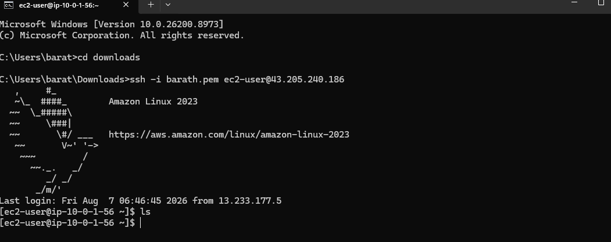

10. Test SSH to Private EC2
Inside public instance
Get private IP of private EC2.
Example:
10.0.3.10
Copy key
scp -i student-key.pem student-key.pem ec2-user@PUBLIC-IP:/home/ec2-user/
SSH
ssh -i student-key.pem ec2-user@10.0.3.10
#Vi ec2.pem inside the copy the key
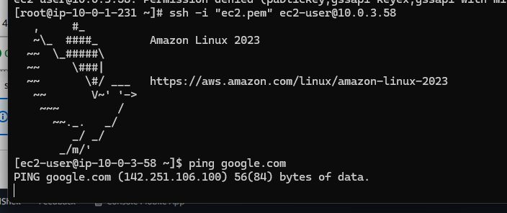

Expected Result
Architecture
Internet
|
Internet Gateway
|
student-vpc
|
------------------------------------
| |
Public Subnet Private Subnet
student-public-subnet-1a student-private-subnet-1a
| |
student-public-ec2 student-private-ec2
| |
-------- SSH Access ----------------
Public VM → SSH → Private VM

Validation Commands
On private VM
hostname
ip a
ping google.com
Expected
Ping should FAIL (no internet)
But
SSH from public should work

If you want, I can also give:
- Advanced VPC Lab (with NAT Gateway)
- 3 Tier Architecture Lab (Web + App + DB)
- 20 AWS VPC Interview Questions used in companies.

